Overview
In this tutorial, we will explore the CAN Bus communication protocol by interfacing the MCP2515 CAN Bus Module with ESP32 microcontroller. Our objective is to transmit data from a DS18B20 temperature sensor over a specified distance using the CAN protocol. In earlier tutorial, we used MCP2515 with Arduino for CAN Bus communication.
The Controller Area Network (CAN) Bus is widely used in industrial settings and automotive diagnostics due to its ability to cover long distances, moderate communication speed, and high reliability. The standard protocols like UART, SPI, and I2C are less reliable over long distances. But CAN is ideal for vehicular systems and environments where communication occurs over extensive wiring. CAN communication typically supports speeds ranging from 50 Kbps to 1 Mbps and can maintain signal integrity over distances from 40 meters at 1 Mbps to up to 1000 meters at 50 Kbps.
We will use a pair of ESP32 boards and MCP2515 modules to demonstrate the transmission of DS18B20 temperature sensor data. The transmitted data will be received by receiver over and is displayed on OLED Display. Let’s get started with today’s guide on CAN Bus communication using the Microchip MCP2515 CAN Bus Module.

Bill of Materials
Here are the list of components that you need for this tutorial
S.N. | Components | Quantity
1 | ESP32 Board | 2 | Amazon | AliExpress
2 | CAN Module MCP2515 | 2 | Amazon | AliExpress
3 | OLED Display | 1 | Amazon | AliExpress
4 | DS18B20 Temperature Sensor | 1 | Amazon | AliExpress
5 | Resistor 4.7K | 1 | Amazon | AliExpress
6 | Jumper Wires | 30 | Amazon | AliExpress
7 | Breadboard | 2 | Amazon | AliExpress

Discover more
MCP2515
Microcontrollers
MCP2515 CAN Bus Controller
microcontrollers
azdelivery MCP2515 CAN Bus Module compatible with Arduino 1x Set
Microcontroller
Arduino
ESP32
Comidox 3pcs Mcp2515 Can Bus Module Tja1050 Receiver SPI Module for Arduino 51 MCU Arm Controller Development Board
microcontroller

MCP2515 CAN Bus Controller Module
The MCP2515 CAN Bus Controller is a simple Module that supports CAN Protocol version 2.0B and can be used for communication at 1Mbps.
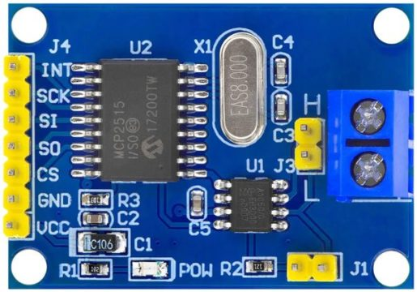
This particular module is based on MCP2515 CAN Controller IC and TJA1050 CAN Transceiver IC. The MCP2515 IC is a standalone CAN Controller and has an integrated SPI Interface for communication with microcontrollers. Coming to the TJA1050 IC, it acts as an interface between the MCP2515 CAN Controller IC and the Physical CAN Bus.
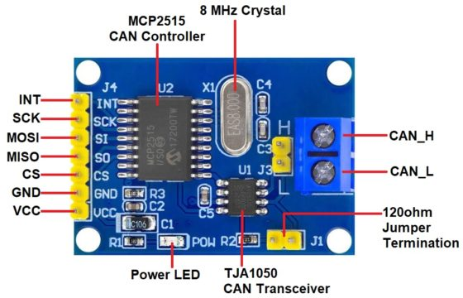
The board has a 8 MHz Crystal oscillator. Even the 16 MHz version is also available. A jumper can be attached which will give 120ohm Termination. CAN_H & CAN_L are the two screws where wires can be attached over a distance for communicating with other CAN Module.
Following is the schematic of MCP2515 CAN Module.
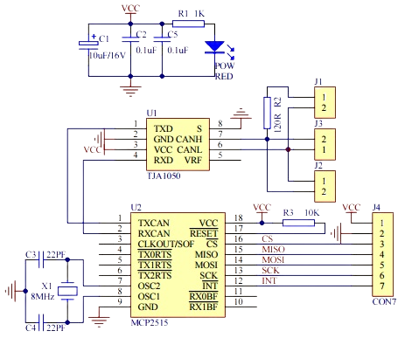
MCP2515 IC is the main controller that internally consists of three main subcomponents: The CAN Module, the Control Logic, and the SPI Block. CAN Module is responsible for transmitting and receiving messages on the CAN Bus. Control Logic handles the setup and operation of the MCP2515 by interfacing all the blocks. The SPI Block is responsible for the SPI communication interface. The TJA1050 IC IC is responsible for taking the data from the controller and relaying it onto the bus.

Features and Specification of MCP2515
- Uses High-speed CAN transceiver TJA1050
- Dimension: 40×28mm
- SPI control for expanding Multi CAN bus interface
- 8MHZ crystal oscillator
- 120Ω terminal resistance
- Has independent key, LED indicator, Power indicator
- Supports 1 Mb/s CAN operation
- Low current standby operation
- Up to 112 nodes can be connected
For more information refer to MCP2515 Datasheet which also has a detailed guide.

Interfacing MCP2515 CAN Bus Module with ESP32
Now let us interface MCP2515 CAN Bus Module with ESP32 Board and test the CAN Communication protocol. We will transmit the DS18B20 Waterproof Temperature Sensor data over a CAN Bus with the help of pair of ESP32 Board & MCP2515 CAN Module. Here is the simple connection diagram.
ESP32 development boards
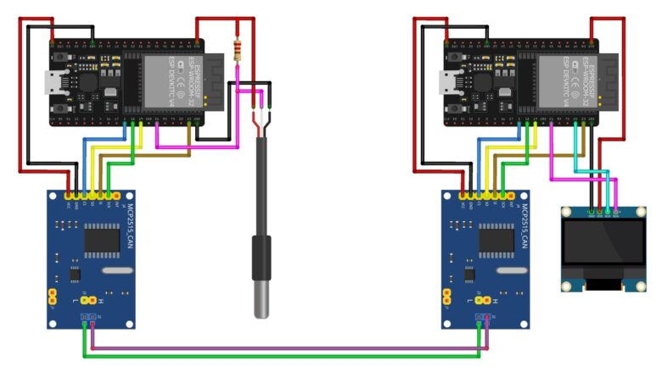
The left part consisting of ESP32 Board, MCP2515 CAN Module & DS18B20 Sensor is a transmitter part.
Similarly, the right part consisting of ESP32 Board, MCP2515 CAN Module & OLED Display is the receiver part.
The transmitter & Receiver Part is connected to each other with the help of the MCP2515 CAN Bus Module. The CAN_H & CAN_L of the transmitter are connected to the CAN_H & CAN_L of the receiver respectively.
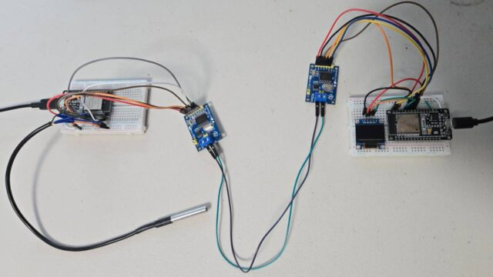
The connection between ESP32 Board & MCP2515 CAN Module is as follows.
MCP2515 Pin | ESP32 Pin
VCC | 5V
GND | GND
CS | IO5
SO | IO19
SI | IO23
SCK | IO13
INT | IO4

On the transmitter part, the DS18B20 Sensor pin is connected to ESP32 IO21 Pin. The DS18B20 Sensor output is connected to VCC via 4.7K resistor.
ESP32 development boards
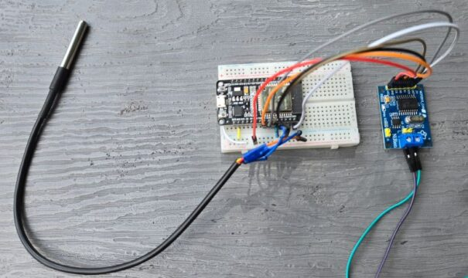
On the receiver part, the I2C OLED Display has 4 pins & VCC, GND, SCL, and SDA. The SCL & SDA are I2C Pins that are connected to the IO22 & IO21 of the ESP32 Board. The VCC & GND of OLED connects to the 3.3V & GND of Arduino.
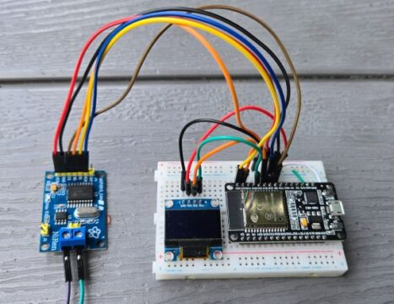
You can assemble the circuit on a breadboard or you can use your own custom PCB for this project.
Arduino boards

Source Code/Program for ESP32 MCP2515 CAN Communication
Before moving to the coding part of the project, we need to install MCP2515 CAN Bus Library to the Arduino IDE. Download the library from the following link and then add it to the Arduino Library folder.
MCP2515 CAN interface Library
This CAN-BUS library gives your ESP32 CAN-BUS capability with the following features.
- Implements CAN V2.0B at up to 1 Mb/s
- SPI Interface up to 10 MHz
- Standard (11 bit) and extended (29 bit) data and remote frames
- Two receive buffers with prioritized message storage
ESP32 development boards
You also need to add OneWire Library as well as Dallas Temperature Library for DS18B20 Temperature sensor.
The code is divided into two parts one as CAN transmitter code and the other as CAN Receiver code.

Discover more
MCP2515 CAN Module
ESP32
Comidox 3pcs Mcp2515 Can Bus Module Tja1050 Receiver SPI Module for Arduino 51 MCU Arm Controller Development Board
Microcontroller
Microcontrollers
Arduino
azdelivery MCP2515 CAN Bus Module compatible with Arduino 1x Set
microcontroller
MCP2515
microcontrollers

ESP32 CAN Transmitter Code

#include <OneWire.h>
#include <DallasTemperature.h>
#include <SPI.h>
#include <mcp2515.h>

#define ONE_WIRE_BUS 21 // GPIO where the DS18B20 is connected
OneWire oneWire(ONE_WIRE_BUS);
DallasTemperature sensors(&oneWire);

struct can_frame canMsg;
struct MCP2515 mcp2515(5); // CS pin is GPIO 5

#define MAX_RETRIES 3
#define CAN_ACK_ID 0x037 // CAN ID for acknowledgment

void setup() {
Serial.begin(115200);
SPI.begin();
mcp2515.reset();
mcp2515.setBitrate(CAN_500KBPS, MCP_8MHZ);
mcp2515.setNormalMode();

sensors.begin();
}

void loop() {
sensors.requestTemperatures();
float temperatureC = sensors.getTempCByIndex(0);
int tempInt = (int)(temperatureC * 100); // Convert temperature to integer for transmission

// Prepare CAN message
canMsg.can_id = 0x036; // CAN ID
canMsg.can_dlc = 2; // Data length code (number of bytes)
canMsg.data[0] = (tempInt >> 8) & 0xFF; // MSB of temperature
canMsg.data[1] = tempInt & 0xFF; // LSB of temperature

bool messageSent = false;
int retries = 0;

while (!messageSent && retries < MAX_RETRIES) {
if (mcp2515.sendMessage(&canMsg) == MCP2515::ERROR_OK) {
Serial.print("Temperature sent: ");
Serial.print(temperatureC);
Serial.println(" °C");

// Wait for acknowledgment
unsigned long startTime = millis();
bool ackReceived = false;

while (millis() - startTime < 500) { // Wait up to 500ms for an ACK
if (mcp2515.readMessage(&canMsg) == MCP2515::ERROR_OK) {
if (canMsg.can_id == CAN_ACK_ID) {
ackReceived = true;
break;
}
}
}

if (ackReceived) {
Serial.println("ACK received");
messageSent = true;
} else {
Serial.println("ACK not received, retrying...");
retries++;
}
} else {
Serial.println("Error sending message, retrying...");
retries++;
}
}

if (!messageSent) {
Serial.println("Failed to send message after retries");
}

delay(1000); // Send data every second
}

ESP32 CAN Receiver Code
ESP32 development boards
#include <SPI.h>
#include <mcp2515.h>
#include <Adafruit_SSD1306.h>

#define SCREEN_WIDTH 128
#define SCREEN_HEIGHT 64
#define OLED_RESET -1
Adafruit_SSD1306 display(SCREEN_WIDTH, SCREEN_HEIGHT, &Wire, OLED_RESET);

struct can_frame canMsg;
struct MCP2515 mcp2515(5); // CS pin is GPIO 5

#define CAN_ACK_ID 0x037 // CAN ID for acknowledgment

void setup()
{
Serial.begin(115200);

display.begin(SSD1306_SWITCHCAPVCC, 0x3C);
display.clearDisplay();
display.setTextColor(WHITE);

SPI.begin();

mcp2515.reset();
mcp2515.setBitrate(CAN_500KBPS, MCP_8MHZ);
mcp2515.setNormalMode();
}

void loop()
{
if (mcp2515.readMessage(&canMsg) == MCP2515::ERROR_OK)
{
if (canMsg.can_id == 0x036) // Check if the message is from the sender
{
int tempInt = (canMsg.data[0] << 8) | canMsg.data[1]; // Combine MSB and LSB
float temperatureC = tempInt / 100.0; // Convert back to float

Serial.print("Temperature received: ");
Serial.print(temperatureC);
Serial.println(" °C");

display.clearDisplay();

display.setTextSize(1);
display.setCursor(25, 10);
display.print("Temperature:");

display.setTextSize(2);
display.setCursor(25, 30);
display.print(temperatureC);
display.print("C");

display.display();

// Send acknowledgment
canMsg.can_id = CAN_ACK_ID; // Use ACK ID
canMsg.can_dlc = 0; // No data needed for ACK
mcp2515.sendMessage(&canMsg);
Serial.println("ACK sent");
}
}
}

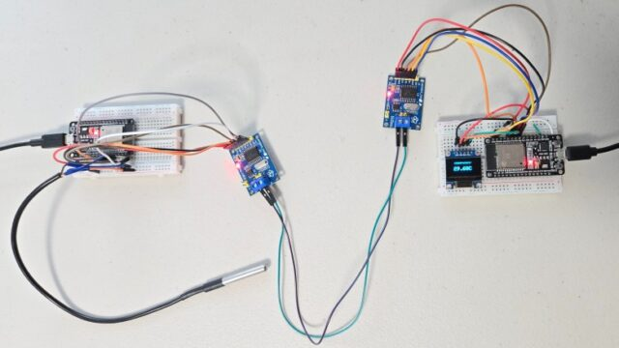

MCP2515 Pin | ESP32 Pin
VCC | 5V
GND | GND
CS | IO5
SO | IO19
SI | IO23
SCK | IO13
INT | IO4

MODBUS RS485

Transmitter

#define TXD2 17 // UART2 TX pin
#define RXD2 16 // UART2 RX pin (for loopback tests)
#define DE_RE 4 // Direction control pin

void setup() {
Serial.begin(115200);
Serial2.begin(9600, SERIAL_8N1, RXD2, TXD2);
pinMode(DE_RE, OUTPUT);
digitalWrite(DE_RE, HIGH); // Enable transmit
}

void loop() {
digitalWrite(DE_RE, HIGH); // Enable transmit
Serial2.write("Hello from ESP32!\n");
delay(1000);
digitalWrite(DE_RE, LOW); // Set to receive after transmit
delay(1000);
}

Receiver

#define TXD2 17
#define RXD2 16
#define DE_RE 4

void setup() {
Serial.begin(115200);
Serial2.begin(9600, SERIAL_8N1, RXD2, TXD2);
pinMode(DE_RE, OUTPUT);
digitalWrite(DE_RE, LOW); // Enable receive
}

void loop() {
if (Serial2.available()) {
char c = Serial2.read();
Serial.write(c);
}
}

Hardware Connections
- TX (transmit) pin of ESP32 → DI (Data In) pin on MAX485.
- RX (receive) pin of ESP32 → RO (Receive Out) pin on MAX485.
- ESP32 GPIO, e.g., GPIO 16 → DE (Driver Enable) and RE (Receiver Enable) pins tied together on MAX485.
- VCC of MAX485 → 5V (or 3.3V if module supports it) power supply.
- GND of MAX485 → ESP32 GND.
- A/B differential pair of MAX485 → RS485 bus wires (A/B twisted pair).
The DE/RE pin is set HIGH for transmit mode and LOW for receive mode. The MAX485 VCC should match its logic compatibility—use level shifting if you must mix 5V MAX485 with 3.3V ESP32.​

ESP32 RS485 Transmitter Example (Arduino Framework)

Typical Connection Table
ESP32 Pin | MAX485 Pin | Purpose
TX (GPIO 17) | DI | UART data out
RX (GPIO 16) | RO | UART data in
GPIO 4 | DE & RE tied | Direction control (TX/RX mode)
GND | GND | Common ground
3.3V or 5V | VCC | Power (see module requirement)
-- | A/B | RS485 differential bus wires
These connections configure the ESP32 and MAX485 module for simple half-duplex RS485 serial communication.​

ESP32 Transmitter Side
- TX (UART, e.g. GPIO 16 on ESP32) → DI (MAX485)
- RX (UART, e.g. GPIO 17 on ESP32, optional for loopback) → RO (MAX485)
- GPIO control pin (e.g., GPIO 4) → DE (MAX485), RE (MAX485) (tie both pins together)
- GND (ESP32) → GND (MAX485)
- 3.3V or 5V (matching MAX485 module requirements) → VCC (MAX485)
- A/B RS485 output → A/B bus wires

ESP32 Receiver Side
- TX (UART, e.g. GPIO 16) → DI (MAX485, optional)
- RX (UART, e.g. GPIO 17) → RO (MAX485)
- GPIO control pin (e.g., GPIO 4) → DE (MAX485), RE (MAX485) (tie both pins together)
- GND → GND
- 3.3V/5V → VCC
- A/B RS485 input → A/B bus wires

Bus Connections
- A (Transmitter MAX485) → A (Receiver MAX485)
- B (Transmitter MAX485) → B (Receiver MAX485)
- Both ends of the RS485 bus (A/B) should have 120Ω termination resistors.

Key Wiring Table
ESP32 (Transmitter) | MAX485 | RS485 Bus | MAX485 | ESP32 (Receiver)
TX (GPIO 16) | DI | A | A | RO (GPIO 17)
RX (GPIO 17, opt.) | RO (opt.) | B | B | DI (GPIO 16, opt.)
GPIO 4 | DE + RE |  | DE + RE | GPIO 4
GND | GND |  | GND | GND
3.3V or 5V | VCC |  | VCC | 3.3V or 5V
This setup enables RS485 data transmission and reception between two ESP32 boards, with clear UART and control connections. Always verify voltage compatibility for each module (most MAX485 modules require 5V, so level shifters may be necessary if ESP32 is operating at 3.3V).​
For schematic visuals, sites like ESP32IO and PCBONLINE provide block diagrams that follow this wiring method.​

ESP32 Transmitter Side
- TX (UART, e.g. GPIO 16 on ESP32) → DI (MAX485)
- RX (UART, e.g. GPIO 17 on ESP32, optional for loopback) → RO (MAX485)
- GPIO control pin (e.g., GPIO 4) → DE (MAX485), RE (MAX485) (tie both pins together)
- GND (ESP32) → GND (MAX485)
- 3.3V or 5V (matching MAX485 module requirements) → VCC (MAX485)
- A/B RS485 output → A/B bus wires

ESP32 Receiver Side
- TX (UART, e.g. GPIO 16) → DI (MAX485, optional)
- RX (UART, e.g. GPIO 17) → RO (MAX485)
- GPIO control pin (e.g., GPIO 4) → DE (MAX485), RE (MAX485) (tie both pins together)
- GND → GND
- 3.3V/5V → VCC
- A/B RS485 input → A/B bus wires

Bus Connections
- A (Transmitter MAX485) → A (Receiver MAX485)
- B (Transmitter MAX485) → B (Receiver MAX485)
- Both ends of the RS485 bus (A/B) should have 120Ω termination resistors.

